Bangkok -Khaoyai 4day3night (pRIVATE)
Tour Highlight: PB valley Khaoyai – Chockchai farm – Sunflower filed -The Pannora Camp& CAFÉ -K-Hmong Alpaca Farm -Hokkaido flower farm


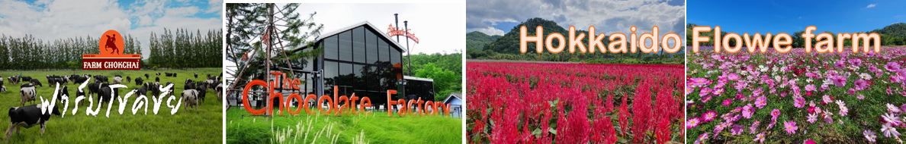

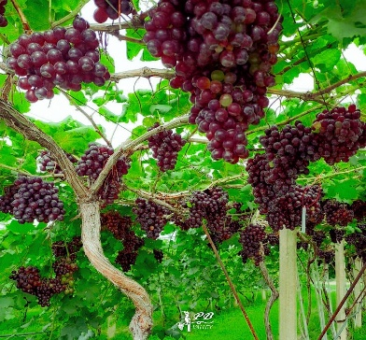
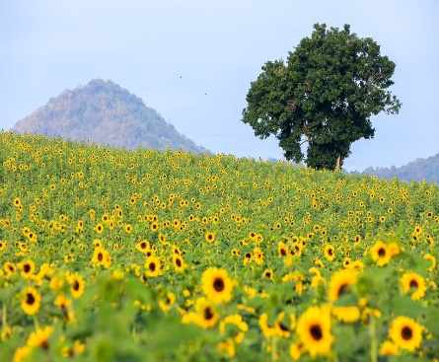
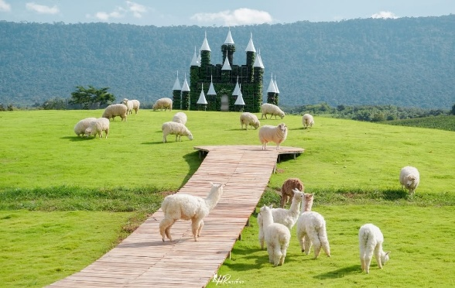

K-Hmong Alpacal farm
PB Valley Gape farm

Itinerary Tour Code: BKY-04

DAY 01 – KUALA LUMPUR – BANGKOK (No Meal)
- Assemble at International Airport for your flight to Bangkok. Upon arrival at Bangkok International Airport, meet and greet, Bantadthong or Joodfair Night street food, Dinner by own , after send to hotel check in

DAY 02 – BANGKOK – KHAO YAI (Breakfast/Lunch/Dinner)
- PB Valley winery the largest winery in Thailand. Here, you will be able to take in the beautiful landscape of the vineyard. Scheduled and private wine tasting tour in PB Valley Estate is available upon request
- Hokkaido Flower Park Khao Yai is a flower field surrounded by mountains and nature. Although there are a dozen flower fields in Khao Yai, this particular one became one of the most popular spots
- Chok Chai Farm: (normally closes on Monday), one of the largest dairy farms in Asia. The farm offers agro-tourism activities with the guide showing the facilities, including the production of raw milk, raising milk cows, milking cows, horse-riding, touring horse stables, dog farms and a zoo.
- Choolate factory & Café
- Pak Chong night market after back to hotel

DAY 03 – KHAO YAI – BANGKOK (Breakfast/Lunch/ Own dinner)
  - Sunflower filed: The season on Nov- Jan
  - The Pannora Camp – Enjoy a breathtaking panoramic view of Khao Yai.
  - K-HMong Alpaka Khaoyai A cozy and charming farm café in Khao Yai where you can meet adorable alpacas, sheep, and other friendly animals. The place is beautifully decorated in a mountain-farm style, surrounded by green scenery and cool weather — perfect for taking photos and relaxing with family or friends.
  - Bangkok’s busiest locations. I-con Siam, In the evening visit Asiatique the Riverfront. Dinner by own

DAY 04 – BANGKOK / KUALA LUMPUR (Breakfast)
- After breakfast, free for your last-minute shopping at the mall nearby.
- Transfer to the Bangkok International Airport for your flight home. with sweet memories

